

C5 Programación_Explorador_Virtual _L2

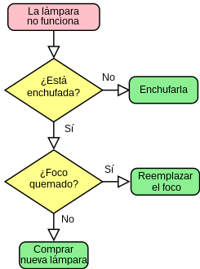*Oscar Ricardo Jurado Zambrano*

*PROFESSOR of ENGLISH: Carlos Moreno*

*Monitor: Diego Vasquez.*

***ACTIVIDAD***

***FORO 5:******Unidad 5 y 6***

*San Juan de Pasto, 24 junio 2025*

***Activity 3: Watch the Video “Cyber Security Awareness Training: Social Media” Video URL:***

[***https://www.youtube.com/watch?v=qgx42ACUVNU***](https://www.youtube.com/watch?v=qgx42ACUVNU)

***Que entendió del video en ingles***

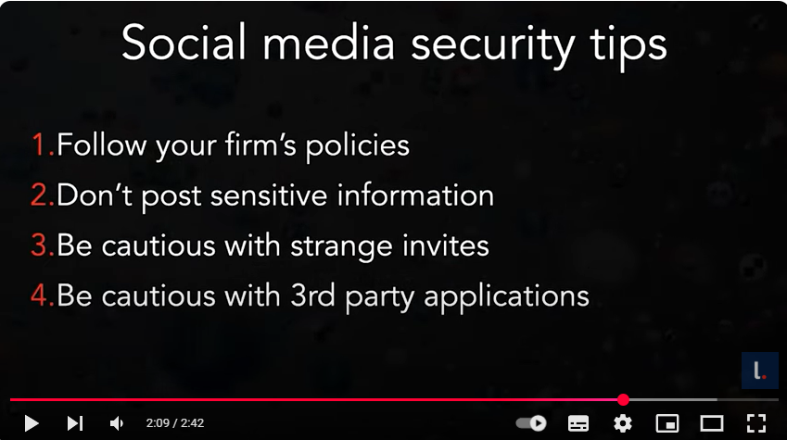

Cyber Security Awareness Training: Social Media <https://www.youtube.com/watch?v=qgx42ACUVNU>

"Las redes se han convertido en un instrumento importante para las personas, no solo a nivel personal sino también profesional. El video da cuatro tips que se deben tener en cuenta para el uso de estas redes. Estos son:

* Seguir las políticas de las empresas
* No entregar información confidencial
* Ser cuidadoso con invitaciones de personas extrañas
* Ser cuidadoso con la aplicación de terceros

***6- Read each of the following statements and decide whether they are true or false based on the reading passage about digital data and privacy.***

Digital technology has made our data more private. **False**

Websites and apps collect data about our online behavior. **True**

Our 'digital footprint' includes our online searches and purchases. **True**

Digital marketing involves making money from our online data. **True**

We always know when and how our data is being used online. **False**

Data breaches can expose our personal information. **True**

The European Union has not created any laws regarding online data. **False**

It is important to understand how our data is used and to demand better protection. **True**

***7- Matching word activity. Based on the reading “What is the internet of things?” , match the word with its correct definition below.***

***Words:***

1.IoT **e**

2.Sensors **f**

3.Cloud Computing **c**

4.Big Data Analytics **d**

5.Cybersecurity **a**

6.Interoperability **b**

7.Sustainability **g**

***Definitions:***

a. The practice of protecting internet-connected systems and data from digital attacks.

b. The ability of different systems and devices to work together without problems.

c. A technology that allows data to be stored and processed over the internet.

d. Analyzing large and varied data sets to uncover patterns and insights.

e. A network of devices with internet connectivity that can collect and share data.

f. Devices that detect changes in the environment like temperature or motion.

g. The ability to maintain processes in a way that avoids wasting natural resources.

***8- Grouping Activity: Understanding IoT. Read the sentences below and decide which category they belong to. The***

***categories are: Technologies in IoT, Applications of IoT, and Challenges in IoT.***

1.IoT devices can monitor the temperature and humidity in manufacturing facilities. ***Applications of IoT***

2.Using IoT in agriculture helps in monitoring soil conditions and crop growth. ***Applications of IoT***

3.In healthcare, IoT devices monitor patients’ vital signs remotely. ***Applications of IoT***

4.Sensors in IoT devices detect environmental changes like temperature. ***Technologies in IoT***

5.Data from IoT devices is stored and processed in the cloud.  ***Applications of IoT***

6.IoT uses technologies like Wi-Fi and Bluetooth for connectivity. ***Applications of IoT***

7.Implementing IoT systems can be expensive and complex. ***Challenges in IoT***

8.IoT can lead to privacy concerns and increase the risk of cyber attacks. ***Challenges in IoT***

9.Managing large volumes of data from IoT devices can be overwhelming. ***Challenges in IoT***

Living in a world where everything is connected to the Internet of Things (IoT) raises several concerns, including:

Privacy Risks – With constant data collection from smart devices, personal information could be exposed or misused.

Security Vulnerabilities – Hackers could exploit weak security in IoT devices to steal data, spy on users, or even take control of critical systems.

Over-Reliance on Technology – If IoT systems fail or get hacked, essential services (like healthcare, transportation, or utilities) could be disrupted.

Data Overload – The massive amount of data generated may be difficult to manage, leading to inefficiencies or misuse.

Lack of Regulation – Weak or inconsistent laws could leave gaps in accountability for data breaches or device malfunctions.

Job Displacement – Automation through IoT might reduce the need for human workers in certain industries.

While IoT offers convenience and efficiency, these concerns highlight the need for strong security measures, privacy protections, and ethical guidelines.

***9- Multiple choice activity: Understanding IoT. Choose the best answer for each of the following questions based on the text "The Internet of Things (IoT)".***

* What is IoT primarily about?

a.Internet services

b.Online gaming

c.Network of interconnected devices

d.Social media platforms

* Which of these is an example of IoT technology in homes?

a.Regular thermostat

b.Smartphone-controlled air conditioner

c.Traditional wristwatch

d.Ordinary light bulb

* IoT, what is the role of sensors?

a.They enhance the device's appearance.

b.They detect changes in the environment.

c.They play music.

d.They display advertisements.

* What does 'Big Data Analytics' in IoT refer to?

a.Storing large files online

b.Analyzing large sets of data for insights

c.Creating big advertisements

d.Designing large IoT devices

* What challenge is associated with IoT regarding data?

a. Too little data to analyze

b. Data overload and its management

c. Data is always lost

d. Data is irrelevant to IoT

* Which industry benefits from IoT through remote patient monitoring?

a. Education

b. Healthcare

c. Agriculture

d. Retail

* What is a significant concern regarding IoT devices?

a. They are too colorful

b. They can't connect to the internet

c. Security and privacy risks

d. They are too large

Vocabulary

Digital Footprint: Huella digital

Purshases: Compras

Challenges: Desafios

devices is stored: Los dispositivos se almacenan

Storing: Almacenamiento

Insights: Perspectivas

Regarding: Acerca de

Concern: Inquietud

